**Web Apps Assignment**

Name: Manush Kumar Kachakayala

SID: S555488

**Git hub Link:** [**https://github.com/44-563-WebApps-F23/44563-webapps-f23-assignment3-Manush18**](https://github.com/44-563-WebApps-F23/44563-webapps-f23-assignment3-Manush18)

**Bonus Link:** [**https://github.com/44-563-WebApps-F23/44563-webapps-f23-assignment3-Manush18/blob/main/Bonus.html**](https://github.com/44-563-WebApps-F23/44563-webapps-f23-assignment3-Manush18/blob/main/Bonus.html)

**Screen shot3 on VS Code of edited index.html.**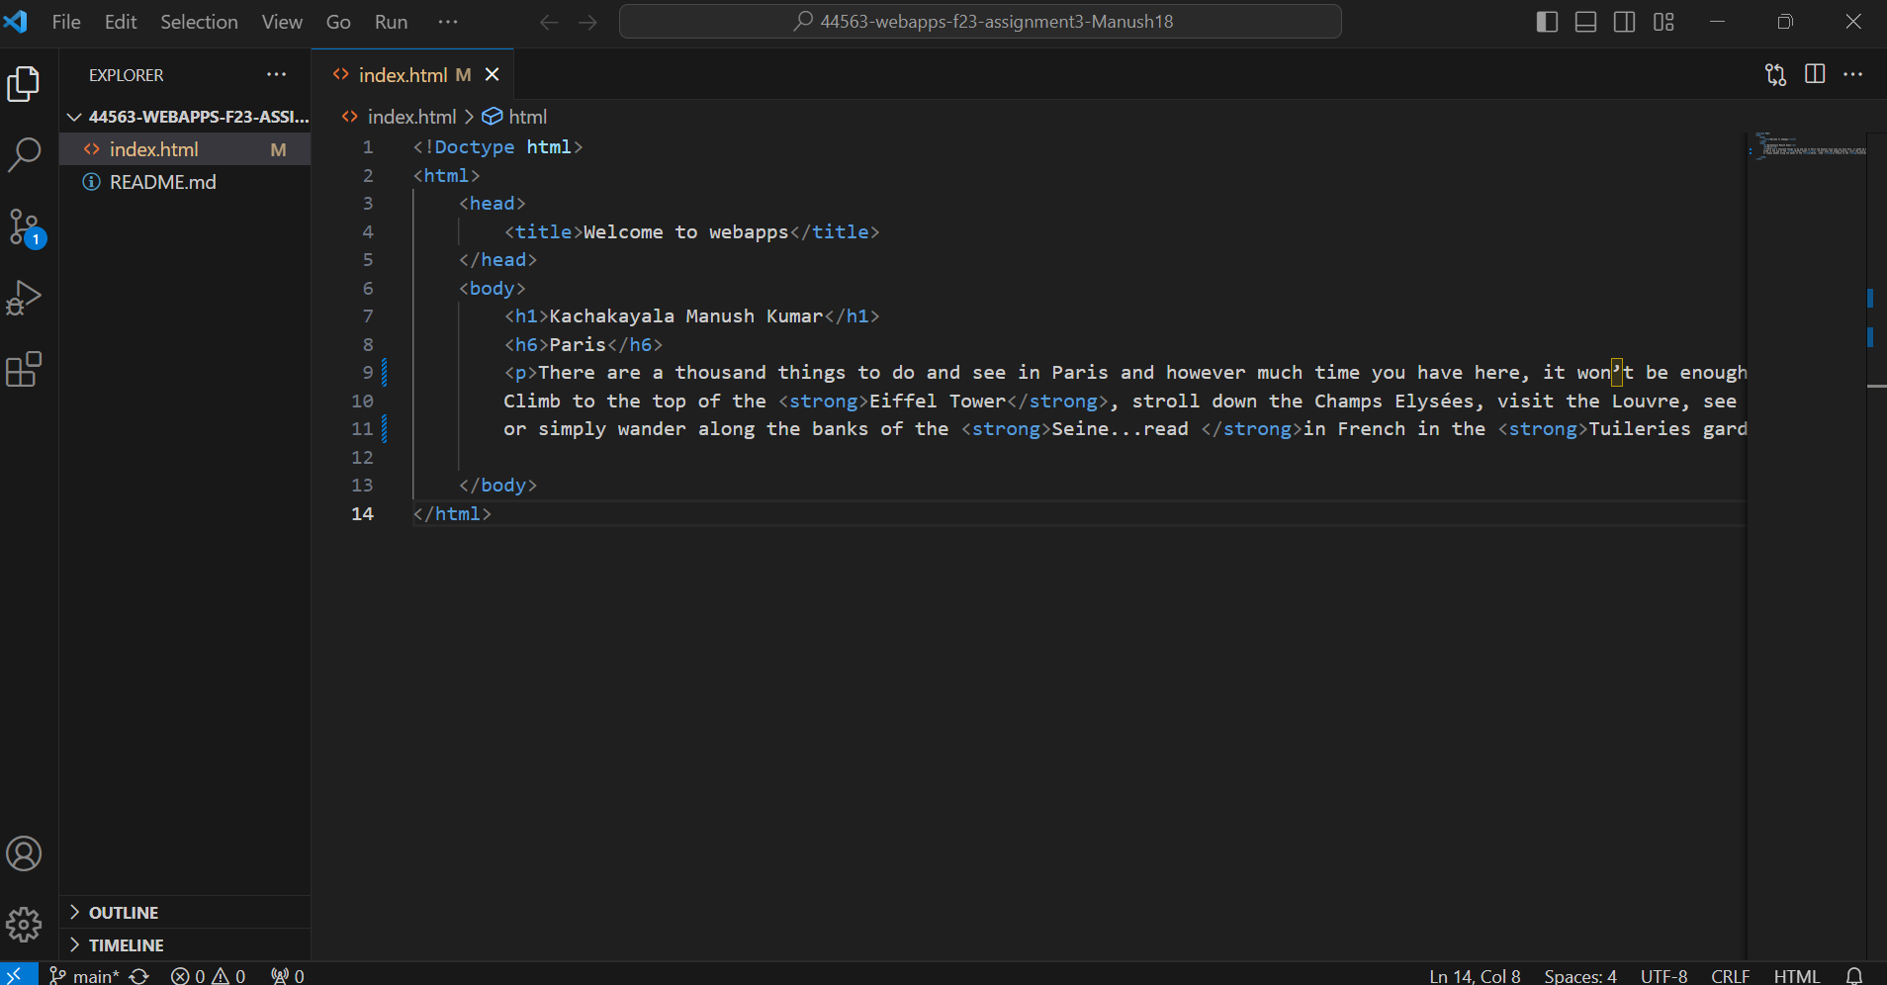

**Screen shot4 on browser showing section**

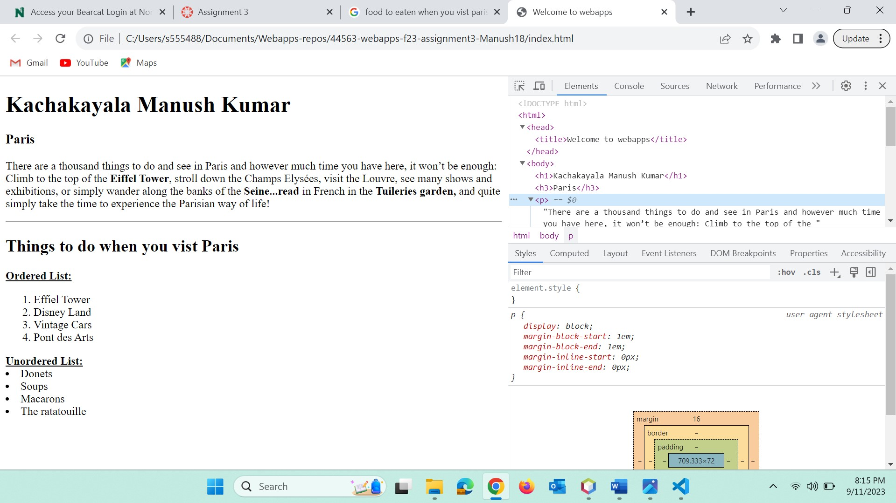

**Screen shot 5 in GitHub desktop showing the state of the repo (or a screenshot of  
git bash running git diff index.html)**

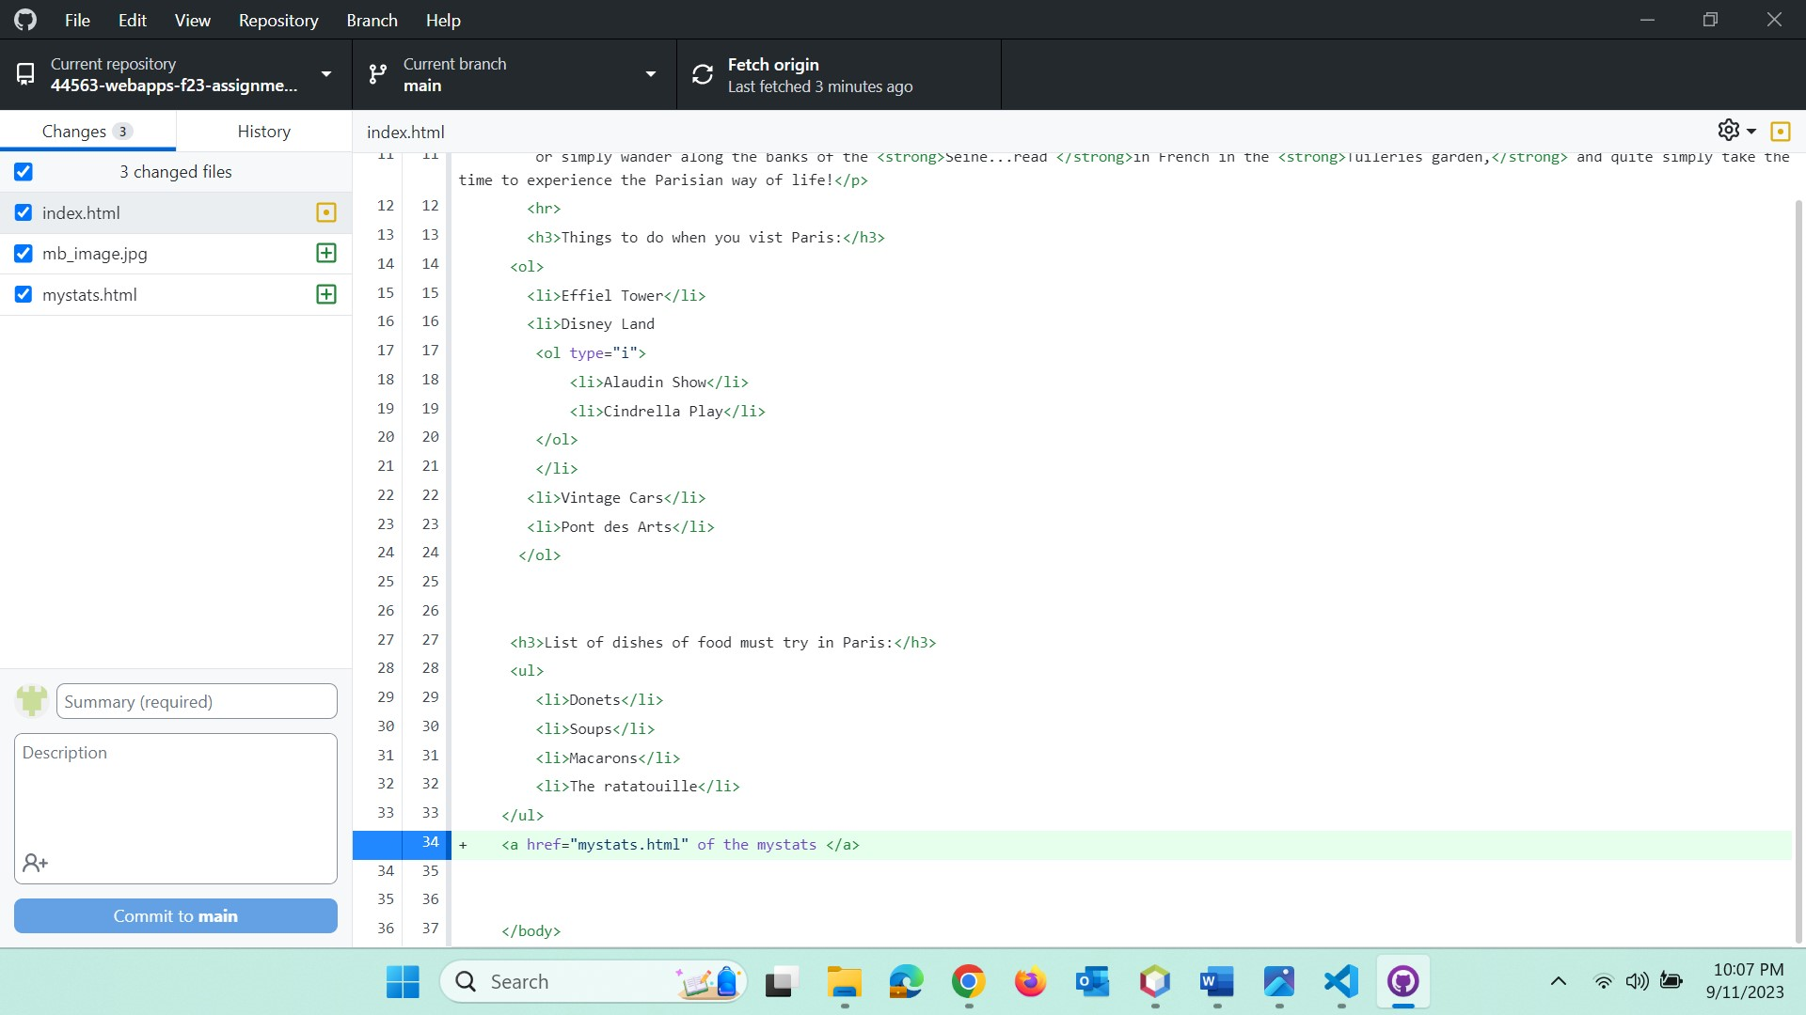

**Screen shot 6 in GitHub desktop showing the changes for mystats me (or a  
screenshot of git bash running git diff mystats.html)**

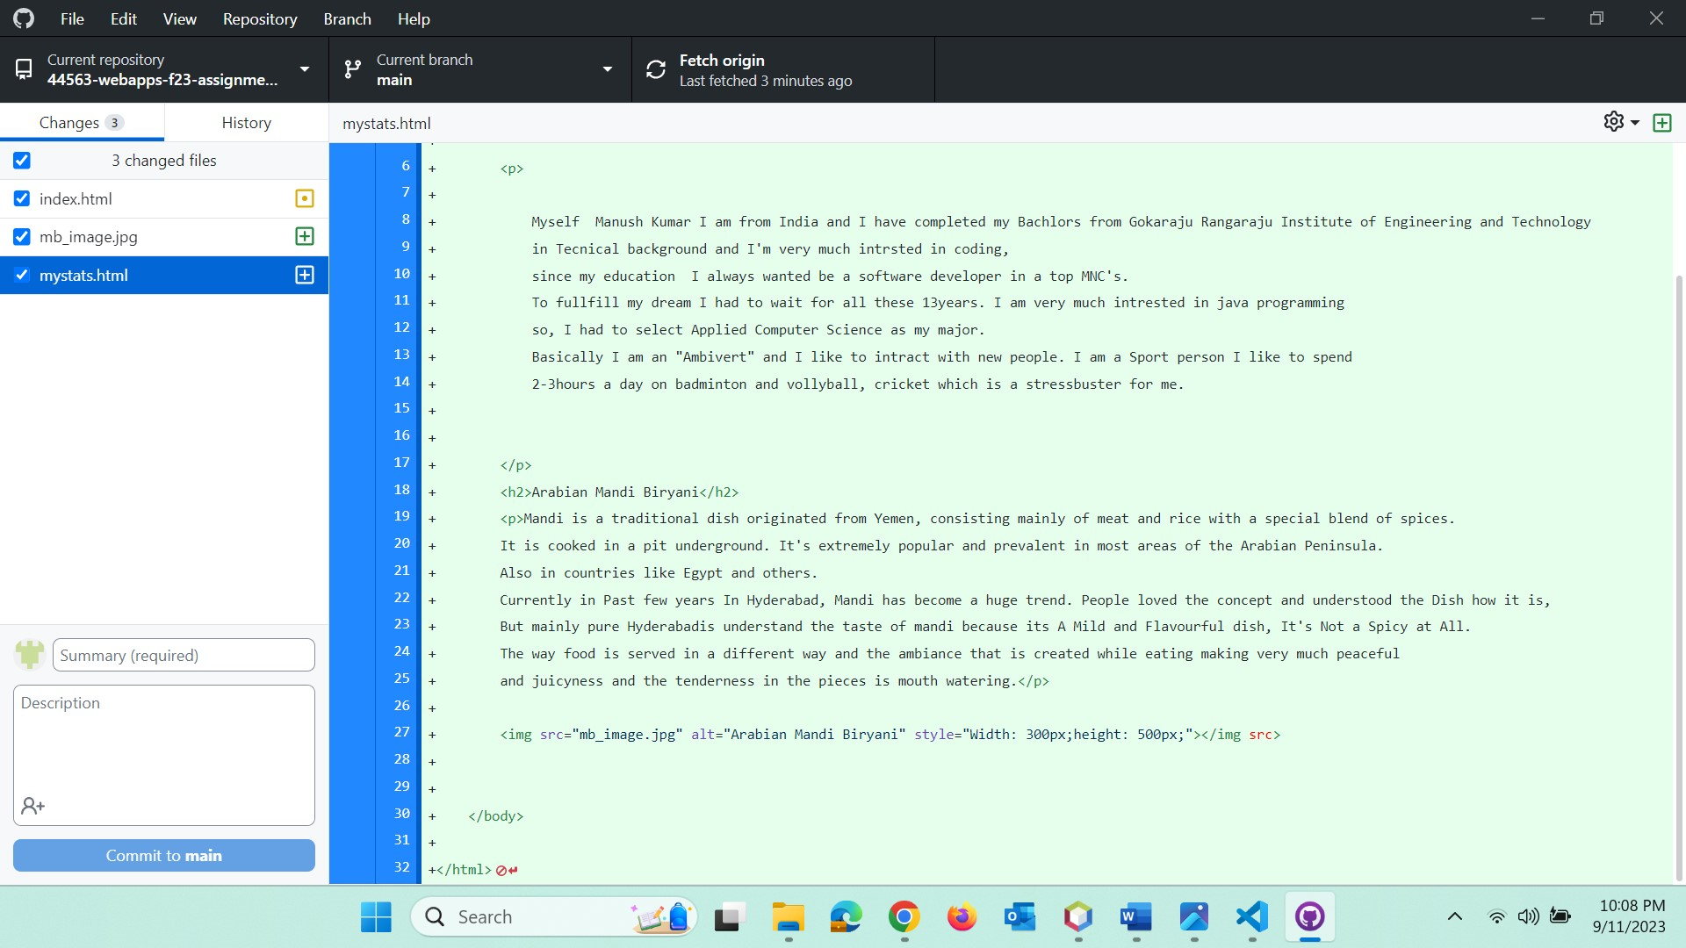

**Screen shot 7 on browser showing table section**

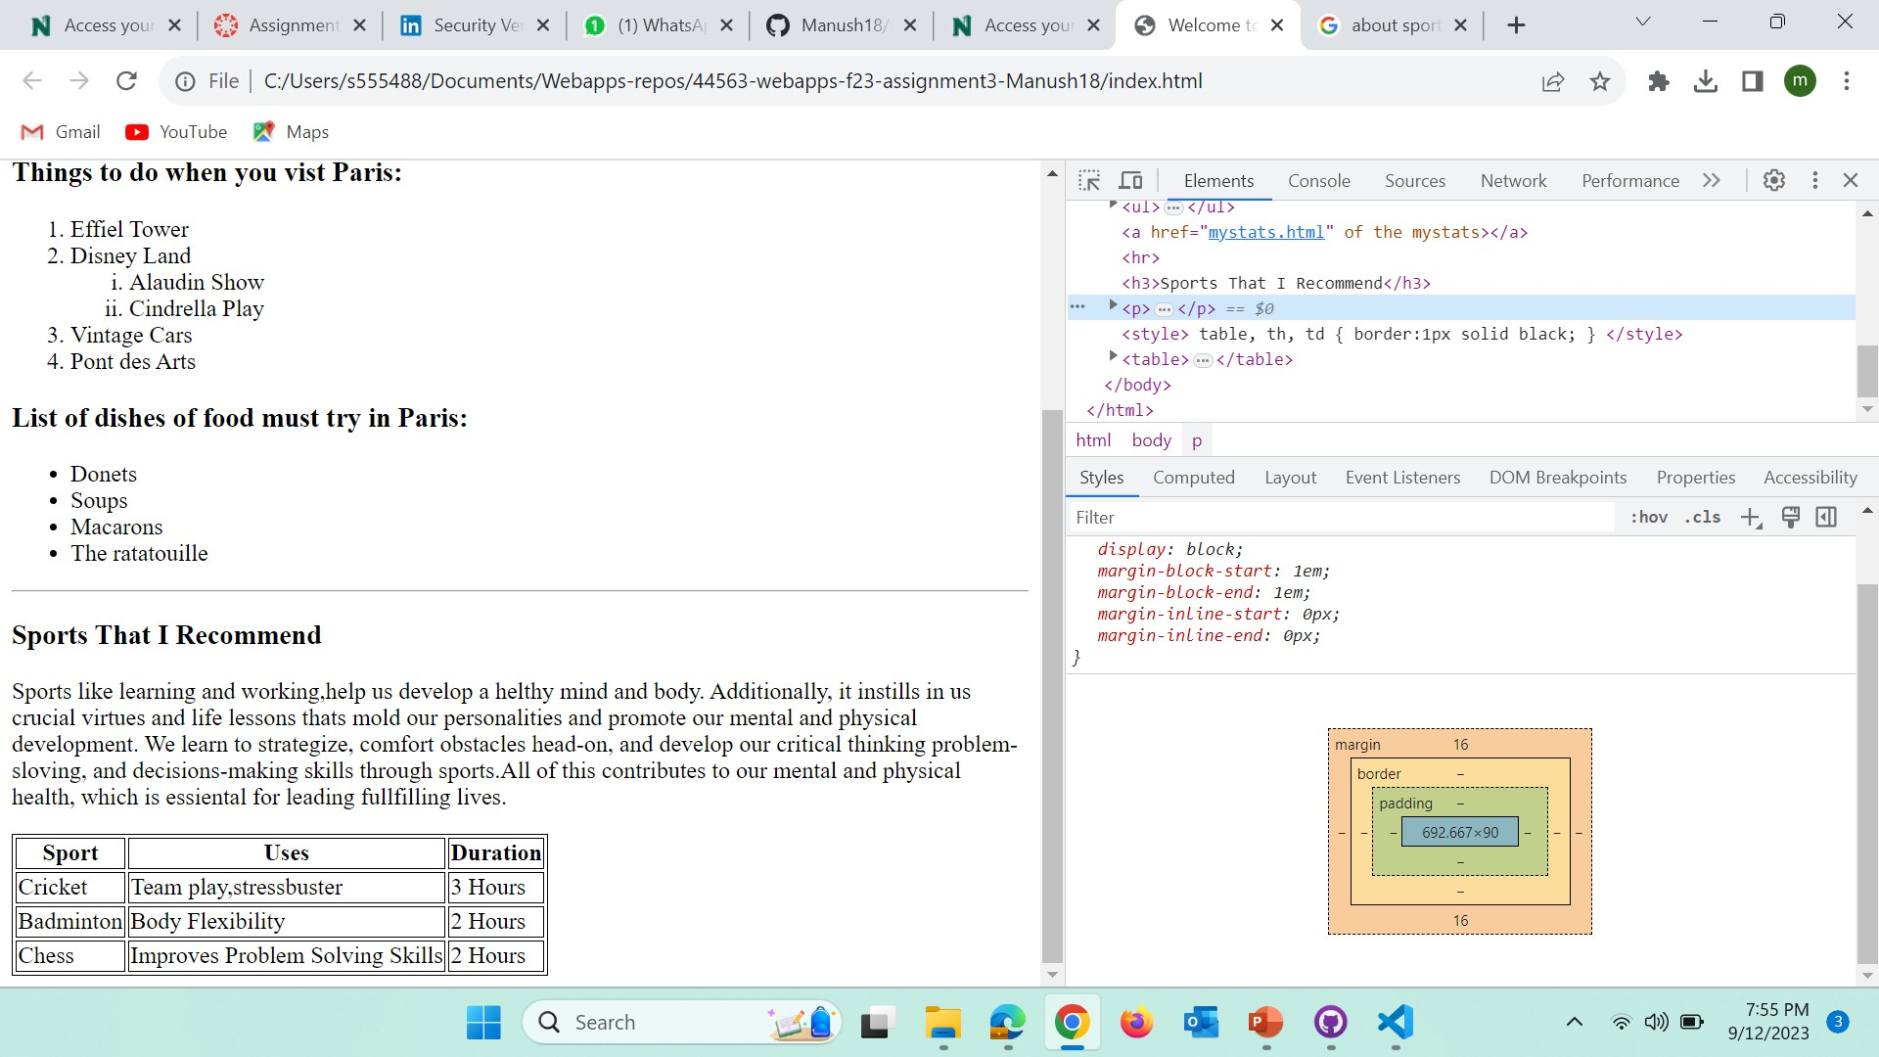

**Screen shot 8 on browser showing code section**

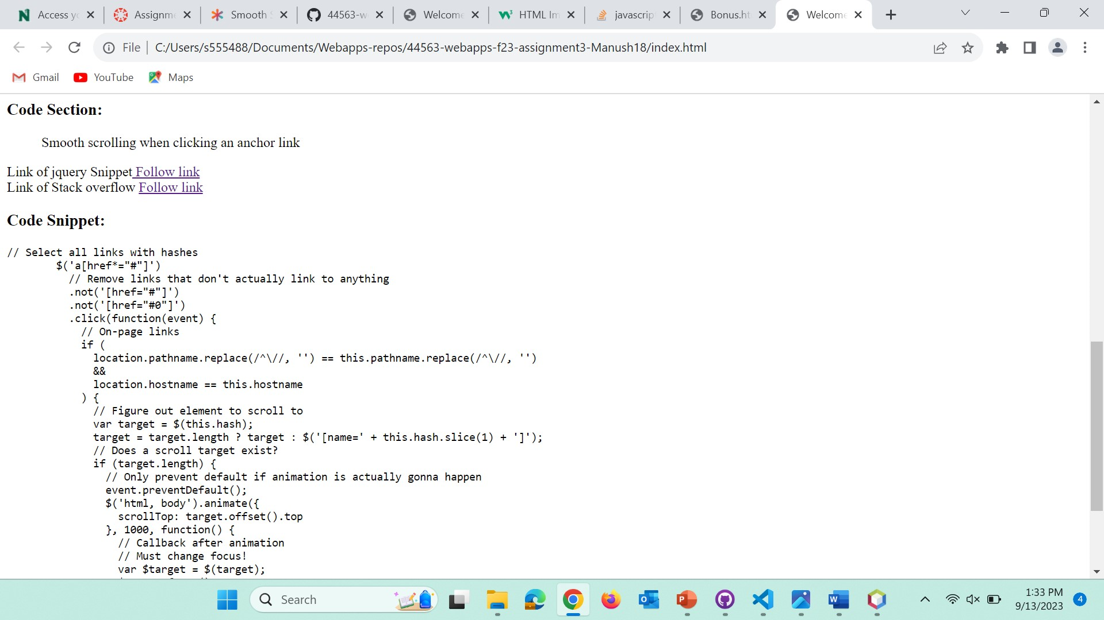

**Bonus Screenshot:**

